**TRACK CHANGER**

**IN HOUSE TRAINING DOCUMENT-ELECTRICAL**

**Version:TC_ 1.01**

**Created Date: -13/10/2021**

**Contents..…………………………………………………………………………………………………………….PAGE NO**

**1.Electrical Parts listing & its Functions……………………………………………………………………......02**

**2.PCB Wiring…………………………………………………………………………………………………………………07**

**3.Electrical Conditions & Run Logic Manual & Auto Operation………………….…………….......10**

**4. Alarms & Troubleshooting …………………………………………………………………………………..……14**

**5 Electrical Preventive Maintenance………………………………………………………………………….….**

1. **Electrical Parts listing & its Functions:**

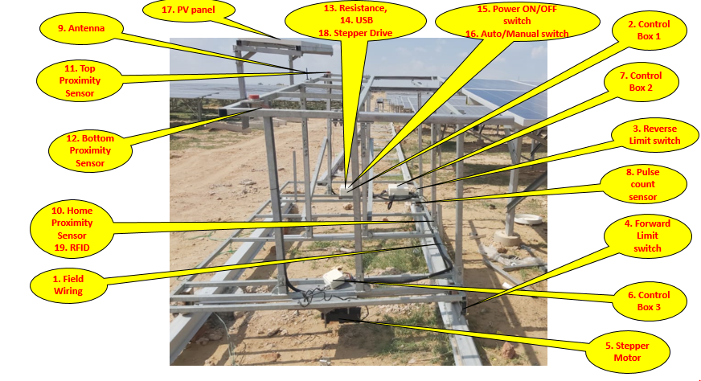

|  |  |  |
| --- | --- | --- |
| **Description** | **Photo** | **Function** |
| **1.Field Wiring** |  | **It is used to link field devices to PCB for input sensing & output run** |
| **2.Control Box with PCB(1 no per cleaner)** |  | **PCB is the main controller which is used to control & monitor the Track changer Movements & communicate with robotic cleaners for auto operations** |
| **3.Limit Switches (Right & Left -2no’s Per Cleaner)** |  | **It is used to avoid Track changer over travel from Rails & stops from derailing at the ends.**  **Limit switches are connected to PCB in (Normally Closed Condition – NC) when signal is cut from limit switches the cleaner movement is restricted in that direction** |
| **4.Stepper Motor (1no per Track Changer)** |  | **1 no of Stepper motor is used for Track changer movement , Stepper motor will be locked in idle conditions** |
| **6. Stepper Drive** |  | **1 no of stepper Driver is used to provide step pulses & direction control to stepper Motor** |
| **7.Battery (1no Per Cleaner)** |  | **24V , lithium battery is used as power source for Track Changer operation.** |
| **8. 2 wire proximity sensors** |  | **1no of proximity sensors used for running confirmation.**  **The sensor sensors metal nut during every rotation**  **We have 1 sensor to sense linear movement confirmation** |
| **9.Distribution Box** |  | **Motor wiring & bottom sensor wiring connected with using extension box** |
| **10.Rocker Switch (power ON/Off 1 no per cleaner)**  **Connectors used for Wires** |  | **We have Main power ON switch to switch ON /OFF the PCB power** |
| **11.Rocker Switch (Auto/Manual- 1 no per cleaner)**  **Soldering done for Wires** |  | **We have Auto /Manual switch which will be always off, when ON it is Manual & local laptop connection for USB cable communication**  **When Auto mode is selected, it will be ZIGBEE wireless communication** |
| **12. USB interface – Wires soldering done at factory** |  | **USB interface is used for connecting the laptop with PCB for troubleshooting & commanding through local laptop** |
| **13. Resistance with clamp (1 no per cleaner)** |  | **Resistance is used for PV charging voltage correction & to avoid high voltage from PV side during non –charging conditions** |
| **14.PV panels (1 to 3 no’s per cleaner-vary as per distance request)** |  | **Solar Panels are used for charging the battery & to run the cleaners, No of panels depends on the requirement of recharging required** |
| **15.Zigbee Antenna (1no Per Cleaner)** |  | **Antenna is used for Wireless communication (ZIGBEE) for distance communications** |
| **16. M50 proximity sensor -3 no’s** |  | **1no of sensor is used for sensing the home position of each row. (we have 1 metal plate fixed in front of each row & this home sensor senses that plate & stops in front of the Row)**  **2 nos of sensors are used to confirm the presence of cleaner on top of the Track changer. 1 bottom sensor placed on bottom of the frame & 1 top sensor placed on top of the frame** |
| **17. RFID reader** |  | **RFID sensor is used to confirm the row no’s . When the reader which is fixed in the TC senses the tag the no of the Tag is read & each tag is mapped to each Row.**  **So track changer is tracked in which row it is stationed at any time, how many rows completed & how much pending.** |
| **18.RFID coins** |  | **RFID tag is fixed to each row along with home sensor plate & each tag carries unique no which will be pre-fixed to each row.** |

**2.WIRING:**

**2.1PCB wiring:**

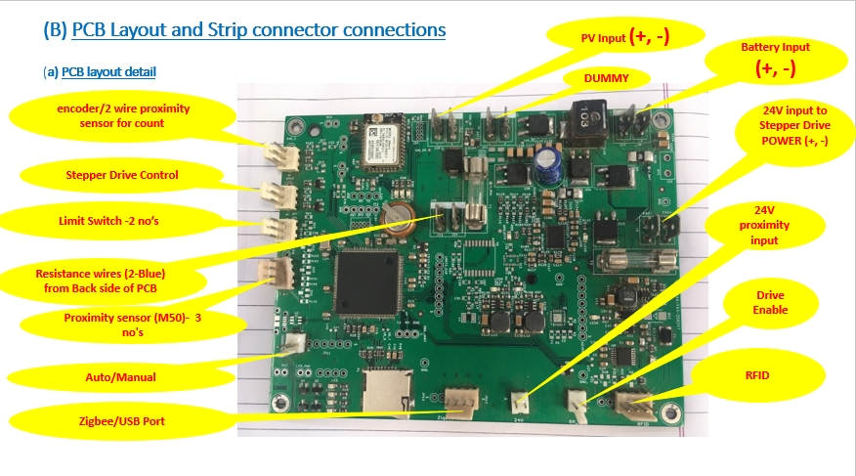

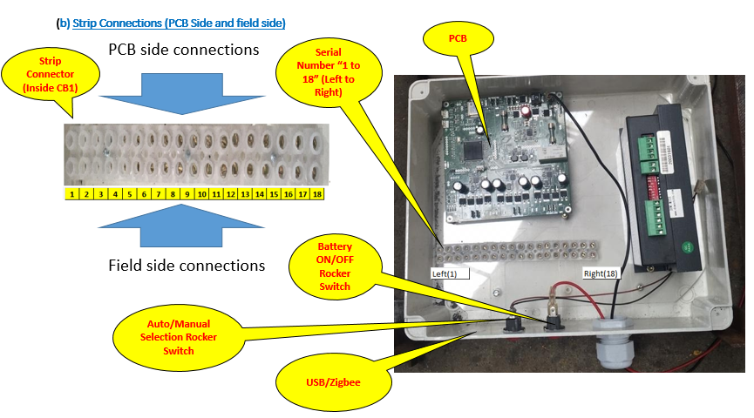

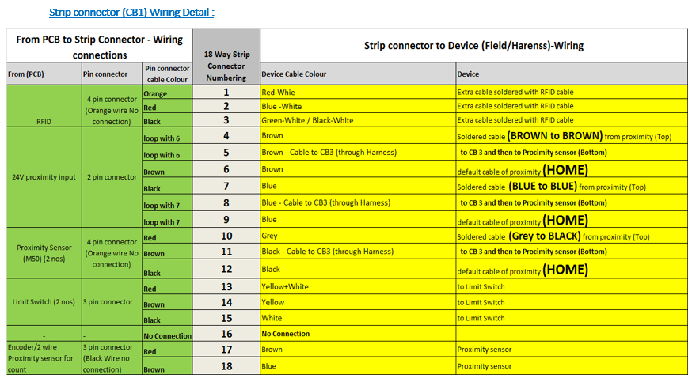

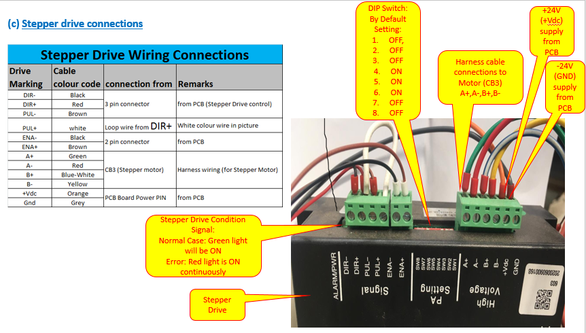

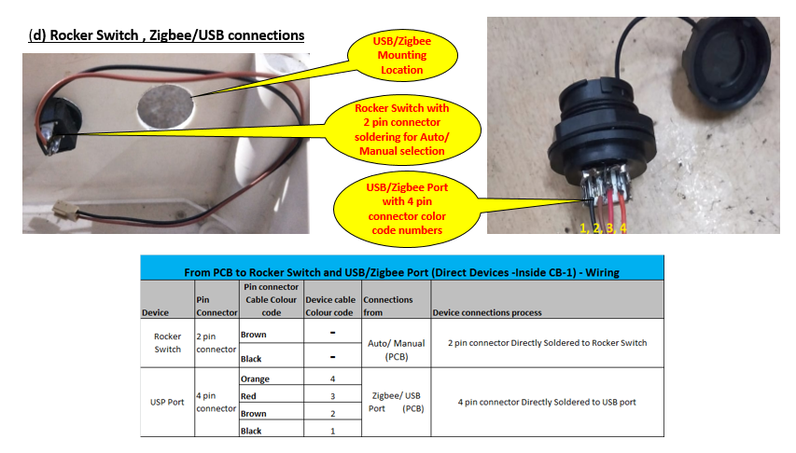

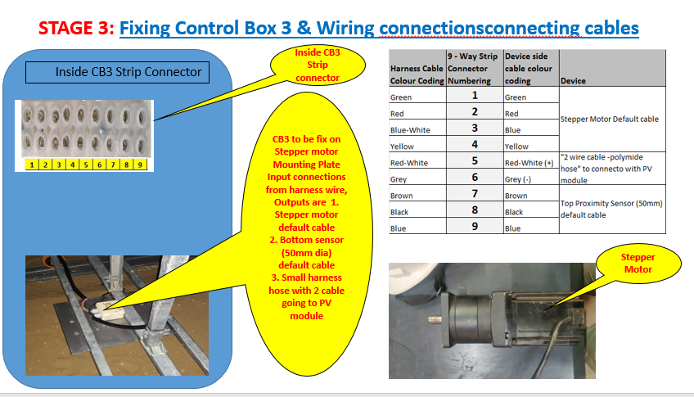

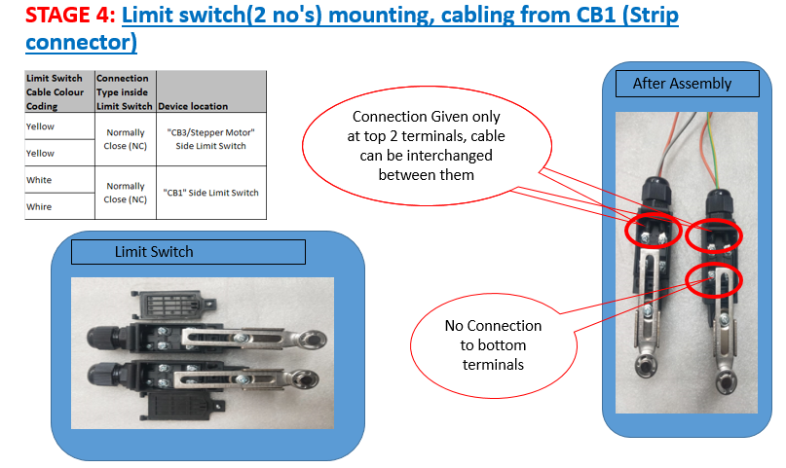

**3.Electrical Conditions, Manual Run, Auto Run Logic:**

**3.1 Electrical Conditions: Power ON switch Should be in ON condition**

**3.1.1Power Section: Battery:**

* **Battery supply should be maintained between Minimum 22V to Maximum 28.3V**
* **Battery State of charge (SOC) should be above 40% out of 100% at any time**
* **Battery charging should be verified on daily check list**
* **Battery connectors should have tight connections & ensure cable routing is good with no loose wires or cut on the wires**

**3.1.2 Power section: PV supply:**

* **PV supply should be around 26V to 36V**
* **PV no’s are depend on the distance coverage by the cleaners & the amount of recharge required**
* **PV voltage should not go above 37V DC, all panels are connected in parallel for power requirement.**

**3.1.3 Fuse & relay:**

* **Glass Fuse is provided on PV section & Battery section (20mm) length.**
* **PV supply side fuse is 6Amps & charging of battery happens only if fuse is OK.**
* **Battery section side fuse is 8Amps & Relay OK light glow only if the battery fuse is ok.**

**3.2 Field Devices:**

**3.2.1 Limit switch:**

* **Limit switch ensures safety of the Track changers from over travelling & derailing down from rails & when limit switch lever is engaged it arrest the movement of the track changer in that direction.**

**3.2.2 Two Wire Proximity sensors:**

**Linear Proximity sensor:**

* **Track changer distance moved in meters are converted to rotational pulse count & feed to PCB.**
* **Forward direction pulse count & reverse direction pulse count is set separately**
* **This count is used to enable slow speed at the approach distance to Row Home.**
* **When the pulse count set is reached double the set point the TC stops its movement in that direction & alarm is generated.**
* **How to calculate the linear distance covered by the TC using the pulse count is mentioned below,**

**For example, if the pulse count is 40 counts, then linear movement moved distance is calculated as follows**

**Wheel Dia in mm, D = 120 mm**

**No of pulse count for example =40 counts**

**PPI Formula =1/($π$*D)*1000 =1/ (3.14*120)*1000 =2.65**

**Distance covered in meters = No.of Pulses / PPI= 40/2.65 = 15.072 meters**

**So if you get 40 counts reading from the movement then the actual distance covered by the cleaner is 15 meters**

**Similar way if you want to set the pulse count from distance use reverse calculations**

**Pulse setting = Distance meters * 2.65**

**3.2.3 M50, 3 wire Proximity sensor**

**It is a metal sensor & sensing range is approx. 20 to 25 mm , It has 3 wires, +VE,-VE 24V supply & 1 output wire.(NPN type).**

**Two no’s of 3 Wire metal proximity sensors are used for confirmation of the Cleaners on top of the Track changer, all sensor inputs are digital output (1 or 0) in Normally open condition. When the cleaner is present on top of the Track changer sensor output will be high (1) & it confirms cleaner presence. The reason for having 2 sensors are to confirm the cleaner straight alignment on top side & bottom side in Track changer. If Track changer needs to start its auto cycle, then both sensor output should be high & when cleaner moves out of track changer if both the sensors are still ON then there can be accident.**

**One no of home sensor is used to get confirmation for track changer to confirm it is position in front of the PV row, if the sensor senses & output is high (1) then the cleaner moves to the PV row for cleaning, Care should be taken to sensor setting is done properly as wrong sensing will end up in cleaner accident or PV panel damage.**

**3.2.4 RFID Reader & Tag**

**RFID reader is used to sense the Row no- one no of RFID tag is fixed to each PV row & row no is mapped to that tag, when the reader fixed in track changer senses the RFID tag it confirms the PV row no & as of now it is only a confirmation & it will not control the cleaner movement.**

**RFID reading distance is around 70mm.**

**3.3Logic settings for Manual Movement**

* **Set the mode of track changer to manual mode from the software in docklite**
* **Precautions like physical condition of cleaner on top of TC, PV row Clearance to track changer mounting & wheel/ rail track clearance has to be taken care by the Engineer before commanding the manual operation.**
* **Send Manual Forward or Manual Reverse command to move the TC either forward or reverse.**
* **The TC will not move if there is alarm conditions present**
* **Even if there is no alarm the TC will be restricted for movement if Limit switch is engaged**
* **Even in manual operation pulse count setting will work & when the set pulse count is reached the TC will run in slow speed in home approach.**
* **TC will stop if either limit switch is activated or manual stop command is given.**
* **Options are available for limit switched to be disabled to run the TC for testing purpose, but care should be taken by Engineer while operating.**

**3.4Logic setting for Auto Movement**

* **Set the Cleaner MAC ID (ZigBee ID) in the TRACK CHANGER to pair the cleaner & TC.**
* **Cleaner & TC will communicate with each other through ZIGBEE for each of its position confirmation, if there is no communication between the two then Auto operation stops. To ensure communication between the two we need to set GATEWAY as co-ordinator.**
* **Set the RTC (Real time clock) for setting the present date & time in both TC & Cleaner.**
* **Set the No of rows & each row Forward & reverse distance in TC**
* **Set the RFID data of each row in TC PCB**
* **Set the Home sensor distance with respect to top & bottom angle of the TC with respect to PV table & care should be taken for maintaining the distance within 25mm.**
* **Set the Auto Schedule time for TC. when the set time is reached then running command for the cleaner will be given from TRACK CHANGER.**
* **Set the Auto PWM (Speed Parameters) to which speed you like to run the Speed. (Range – 1M/min to 2.5 M/Min)**
* **Set the pulse count setting for slow speed operations at the home approach distance.**
* **Ensure cleaner presence top sensor & bottom sensor are sensing the cleaner properly when the cleaner is positioned on TC in home conditions. If the sensor is not sensing, then TC auto operation stops.**
* **Set the mode of Track changer & cleaner to Auto mode from the software.**
* **Check for alarms & Battery SOC before run in both TC & its cleaner, if any alarm in cleaner it stops auto cycle.**

**Data Setting for running**

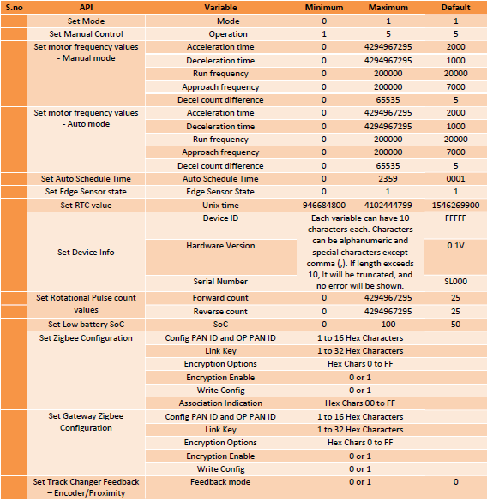

**4. Alarms & Troubleshooting**

|  |  |  |  |
| --- | --- | --- | --- |
| To Get Error Status | Open Docklite software in PC , connect the USB communication cable between PC & PCB, Switch ON PS1 Switch | Get Error Status Parameter no 1018 | Check if the received value is "0" if other values are received there is an error ,request to check the manual for error codes |

**Note: For any errors you have to check both the Track changer & its paired cleaner.**

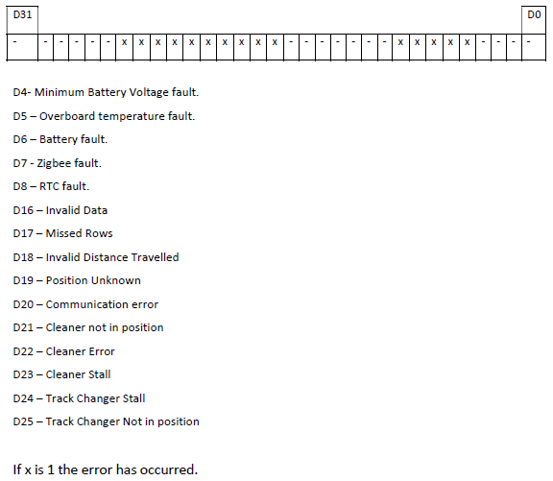

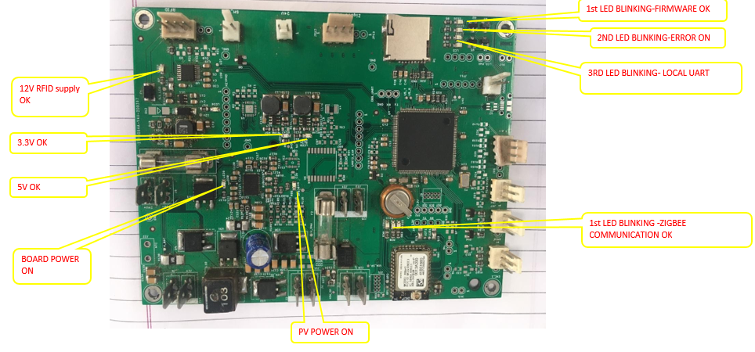

|  |  |  |  |  |  |  |  |
| --- | --- | --- | --- | --- | --- | --- | --- |
| **S.** | **Fault** | **Fault** | **Clearing Methods** | | **Robot State** | **Robot State** | **Other** |
| **No** | **Code (HEX values)** | **Description** | **Clear Faults API** | **Set Mode API and Manual Movement Control**  **API** | **After Fault Occurrence** | **after Fault Clear** |  |
| **1** | 00 | NO FAULT | - | - | - | - | - |
| **2** | 10 | Minimum Battery Voltage Fault | Y | Y | Robot Stops | Robot Stop | Will automatically come out of Fault if Battery SoC exceeds the low battery SoC+ Hysteresis Hysteresis is hardcoded as  2%. |
| **3** | 20 | Board  Temperature Exceeded fault | Y | Y | Robot Stops | Robot Stop |  |
| **4** | 40 | Battery Fault | Y | N | Robot Stops | Robot Stop |  |
| **5** | 80 | Zigbee Fault | Y | N | No Change | No Change | May require a Restart to function  properly. |
| **6** | 100 | RTC Failure | Y | Can be  cleared when RTC is set | AUTO Mode is disabled | AUTO Mode is enabled. | Set RTC & check  If hardware  Fault, may require a restart |
| **7** | 10000 | Invalid data | Y | N | Robot won’t  start | Robot Stop | When the data format is not followed, this error will occur ,see the data format |
| **8** | 20000 | Missed Rows | Y | N | Robot Stops | Robot Stop | When a TC misses the home sensor of the row with particular distance movement, ensure home sensor sensing |
| **9** | 40000 | Invalid Distance  Travelled | Y | N | Robot Stops | Robot Stop | When the set distance for the rows is not reached within particular time, ensure distance set & home sensor sensing are ok |
| **10** | 80000 | Position  Unknown | Y | N | Robot Stops | Robot Stop | When the TC is not started from its home position then row no will be unknown, make TC home & restart in auto |
| **11** | 100000 | Communication  error | Y | N | Robot Stops | Robot Stop | When a TC & Cleaner communication breaks this error will happen, reset the communication of TC, Cleaner & it gateway |
| **12** | 200000 | Cleaner not in  position | Y | N | Robot Stops | Robot Stop | When the TC move Auto command given but cleaner presence top sensor & bottom sensor not sensing the robo presence – Check the robo home & sensor condition |
| **13** | 400000 | Cleaner Error | Y | N | Robot Stops | Robot Stop | There is some error in cleaner which , reset the cleaner & start the TC |
| **14** | 800000 | Cleaner Stall | Y | N | Robot Stops | Robot Stop | In Auto mode when TC gives command for cleaner to run but cleaner is stopped in TC without any alarms in cleaner (or) TC bottom & top sensor malfunctions this alarm is generated, check the sensor & Cleaner |
| **15** | 1000000 | Track Changer  Stall | Y | N | Robot Stops | Robot Stop | When the run command to TC is given but TC struck at same place & not moving. Check the rail & Wheel & restart again |
| **16** | 2000000 | Track changer  not in position | Y | N | Robot Stops | Robot Stop | When the Cleaner is in operation & during the time TC moved or home sensor sensing is lost then we get this. Check for TC position in line with home sensor. |

**5. Preventive Maintenance**

|  |  |  |  |  |  |
| --- | --- | --- | --- | --- | --- |
| **Points To Check** | **What to Check** | **How to Check** | **When To Do** | **Final Action** | **Remarks** |
| Limit switch | 1)Lever Condition | Spring return to original position after Lever to pressed opposite side | Weekly | Clear the Dust entry in spring |  |
| 2)NC closing | To check with manual operation & restrict the movement | Weekly | Retighten the wires |  |
| Battery | 1)Positioning of battery in Mounting plate | Visual check of battery mounting | Monthly | Correct the mounting |  |
| 2)Connector & cable routing | Visual check of connectors & cable routing | Monthly | Reroute |  |
| 3)Battery Charging & SOC levels | To Check through PC/SCADA for SOC levels & Battery Charging | Daily | Check the PV & BAT |  |
| Wire set | Cable conduit routing | Visual check of connectors & cable routing | Monthly | Reroute |  |
| Rat bite on cables | Visual Check on cable & conduit cuts | Monthly | Clear the cut areas |  |
| PCB Box | PCB top cover mounting | All screws mounting & no gap in Covers | Half Yearly | Retighten |  |
| Cable conduit & tightness | Visual check of connectors & cable routing | Half Yearly | Retighten |  |
| PCB | Dust settling over the PCB | Visual Check for dust on the top of the PCB | Half Yearly | Clean the dust using a Soft brush |  |
| PCB mounting screws | Check for Screw mounting tightness | Half Yearly | Retighten |  |
| Solar Panel | PV panel top surface | Visual Check for dust on the top of the PV panel | Weekly | Clean surface without dust |  |
| Check the Connectors & cable routing | Visual check of connectors & cable routing | Monthly | Retighten & re route |  |
| Check for Open Voltage & Charging current | To Check through PC/SCADA for PV voltage & Current | Daily | Run & Check & record data |  |
| Proximity Sensors | Check for mounting tightness | Check for Screw mounting tightness & vibration | Half Yearly | Retighten |  |
| Check the Connectors & cable routing | Visual check of connectors & cable routing | Monthly | Retighten & re route |  |
| Check for the Sensing distance | Measure the sensing distance & ensure it is 20mm for 50 dia sensor & 3 mm for 8mm sensor | Monthly | Clean the face area & ensure mounting straightness |  |
| Stepper Motor | Check for Motor mounting | Check for Screw mounting tightness & vibration | Half Yearly | Retighten |  |
| Check the Connectors & cable routing | Visual check of connectors & cable routing | Monthly | Retighten & re route |  |
| Check for the Carbon Brush | Visual check of Carbon brush wear after dismantling the motor cover | Annual | Clean Copper Rotor & proper brush impression with spring tension |  |
| Check for Running Amps | To Check through multimeter | Monthly | Run & Check & record data |  |

**------------------------------------------------------END OF DOCUMENT-----------------------------------------------------------------------**